Software Architecture Document

Automated Dormant Account Closure System 0.1

**Revision History**

|  |  |  |  |
| --- | --- | --- | --- |
| **Date** | **Version** | **Description** | **Author** |
| 04/15/2020 | 0.1 | Draft version | Ankush Apte |

**Table of** **Contents**

1. Introduction 1

1.1 Problem statement 2

1.2 Proposed Solution as a Proof of concept 2

1.3 Scope and Features 2

1.4 Technology Used 2

2. Module Design 3

1.5 Context diagram 3

3. Future enhancements & quality 3

1. Introduction

This document describes high level overview of Automated Dormant Account Closure System for Banking industry. This is Proof of concept, which builds the automated process to ease the manual activities performed by operation team.

* 1. Problem statement

Some of the Banking operation team in financial institutes are still performing manual activities to close the dormant or inactive accounts based on recurring customer interaction. Based on customer feedback and completing financial regulators compliance formalities closure activity is getting performed. This involves lot of manual repetitive activities.

* 1. Proposed Solution as a Proof of concept

This Software Design Description (SDD) describes the high level technical architectural overview for proposed solution for ADACI system and the precise implementation details required to satisfy the requirements. As a part of Proof of concept, we will be developing new automated process which will help to perform account closure activity for dormant / inactive accounts. Bank operation team will be authorized to access UI interface based on roles and permissions, this UI interface will track the account closure process by defining workflow by using compliance rule engine.

* 1. Scope and Features

The design description defined in this document serves multiple purposes: Ease & Automate the overall process around the account closure process by using New Online interface, improves operational efficiency and overall turnaround time. Solution must support below features

* Rich User Interfaces/Single Page App that brings the Better User Experience for all handheld devices.
* Reporting functionalities like User Activity, Audit Report in PDF or Excel format
* Maker – Checker workflow & compliance rule engine.
* Feature supporting decisional review process.
* PDF or Excel Import functionality to support the Offline Processing details.
* Role based Authentication and authorization mechanisms
  1. Technology Used
* User Interface: Angular with Node JS.
* DB :  Open source SQL or No SQL DB.
* Data Extractor: Processed Length File or Piped Delimiter File.   ( Out of Scope )

1. Module Design

This section elaborates & provides overview of high level design of proposed solution

* 1. Context diagram

Below shows the context diagram for the proposed system.

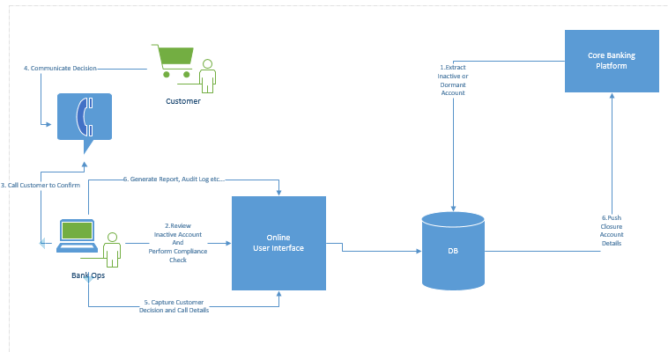

1. Future enhancements & quality

As far as the online catering application is concerned, the following quality goals have been identified:

Scalability:

* Description : System’s reaction when user demands increase
* Solution : J2EE application servers support several workload management techniques

Reliability**,** Availability**:**

* Description : Transparent failover mechanism, mean-time-between-failure\
* Solution : : J2EE application server supports load balancing through clusters

Portability:

* Description : Ability to be reused in another environment
* Solution : The system me be fully J2EE compliant and thus can be deploy onto any J2EE application server